Khandallah Village Street Fair

Health and Safety Policy
  - Date: November 2019 Review: October 2020

Contents
Contents 1
Purpose 2
Description of Operations 2
Policy 2
Responsibilities 3
Our Policies and Procedures 4
Health and Safety Objectives for 2018 4
Communication 5
Health and Welfare 7
Risk Management 7
Incidents 8
Emergencies 9
Transport and Parking 11
Relevant Legislation and Guides 12

Purpose
Our vision is that our volunteer workers, stallholders, members of the public, and other people affected by our work, always have the best practicable opportunity to be healthy and safe preparing for, and while at, the fair. This policy outlines the principles we put into practice to achieve this.

Description of Operations
Event Title Khandallah Village Street Fair
Date 8 December 2019
Location Ganges Road (btw Agra Cres & Dekka St), Khandallah
Time 10.00am – 2.00pm
Email info@khandallahfair.nz
Website http://www.khandallahfair.nz/
Organisers Rotary Wellington Kaukau Incorporated
Reason Raising of funds for local community projects and the End Polio Now programme
Stallholders They are professional craft people, local organisations, or the general public advertising their wares
Sites Stallholders hire either one site or more, to suit their operation. Sites are down the middle of Ganges Road, with the public walking between the edge of the stalls and the footpaths. Some shops have opted to open and may sell their wares outside their shop fronts. The town hall will be open for entertainment and Devonshire teas. There will be stalls inside the old video shop at 5 Ganges Road. There will be a few food and beverage vendors at various sites

Policy
To ensure a safe and healthy environment, our leaders will develop and maintain a health and safety management system. Specifically, we will:
- ensure the provision of bathroom facilities, drinking water, and shelter for the welfare of all volunteer workers, stallholders, and members of the public
- identify all existing and new risks and take all practicable steps to eliminate or minimise the exposure to any risks, with first priority on eliminating the highest rated risks
- ensure that volunteer workers and stallholders are made aware of the risks in their work area and are adequately trained and informed to enable them to perform their duties in a safe manner
- actively encourage the accurate and timely reporting and recording of all incidents and injuries
- investigate all reported incidents and injuries to ensure all contributing factors are also identified and, where appropriate, plans are formulated to take corrective action
- actively encourage the early reporting of any pain or discomfort
- work with affected volunteer workers, stallholders, and members of the public to ensure they receive the right treatment for a durable recovery and return to regular activities
- encourage volunteer worker and stallholder consultation and participation in all matters relating to health and safety
- promote a system of continuous improvement, including the annual review of policies and procedures.
- meet our obligations under the Health and Safety at Work Act 2015 and relevant Regulations, Codes of Practice, and Standards or Guidelines.

Responsibilities
Each Volunteer Worker and Stallholder is expected to play a vital and responsible role in maintaining a safe and healthy workplace:
- Take responsibility for own safety, health and wellbeing
- Observe all safe work procedures, rules and instructions
- Seek advice and training if unfamiliar with procedures or equipment
- Report any pain or discomfort early
- Actively participate in treatment and rehabilitation following any injury
- Ensure all incidents, injuries and risks are reported to a leader
- Actively check and manage the safety of their workplace.
The following are Leader roles:
- Convenor: Russell Law
- Head Marshall: Prue Harrison
These roles are supported by a Health and Safety Officer (Jane Bambery) and a Traffic Manager (Traffic Management NZ).
Each Leader has a responsibility for the health and safety of those volunteer workers, stallholders, and members of the public with whom they have influence and for preventing harm in their workplace:
- Ensure volunteer workers and stallholders are familiar with policies, risk identification and management, and incident and emergency response procedures appropriate to their workplaces
- Prompt and accurate hazard identification, update of the risk register, and incident investigation
- Active communication with volunteer workers, stallholders, and members of the public
- Notifiable Event response - completion of Notifiable Event reports
- Corrective actions required and completed in response to incidents
- Emergency preparedness and response
- Liaise with workers, stallholders, and members of the public to promote their health and respond to significant discomfort or any injury
- Induction and monitoring of stallholders and other contractors or visitors.

Additionally, the Convenor is responsible for:
- Health and Safety policy and continuous improvement
- arranging bathroom facilities, drinking water, and sufficient shelter for the programme’s duration
- sufficient worker training and engagement with Health and Safety
- verifying competence of Leaders, Health and Safety trainers and Contractors
- organising Health and Safety meetings
- reviewing the risk register and incident trends and follow up the completion of corrective actions and any resultant updates to risk register, procedures, or policies
- organising the review of policies, registers, training, plans and procedures.

Our Policies and Procedures
Document Name | Leader | Voluntary Worker | Stallholder
Health and Safety Policy
Risk Register
Marshalls Information
Stall Site Application
Rides & Activities Health and Safety Questionnaire
Notification of a Food Stall
Marshal Checklist
Rubbish Collection Guidelines
Parking Patrol Guidelines

Health and Safety Objectives for 2019
- Have a health and safety policy that reflects the nature of the Fair activities
- A working, up-to-date risk register that is observed by all volunteer workers, stallholders and shopkeepers who extend their shop frontage
- Check the safety of all stalls and extended shop frontages
- No incidents requiring medical treatment
- Develop procedures to actively share relevant health and safety information with other groups such as Parking volunteer groups, Wellington City Council, Greater Wellington Regional Council, NZ Police, Wellington Free Ambulance Service, and NZ Fire Service
- Review and update of all policies and procedures before the beginning of the 2020 fair.

Communication

Communication Methods
Website http://www.khandallahfair.nz/ – to communicate with Stallholders and members of the public
Facebook Rotary Kaukau
Email Info@khandallahfair.com
Posters for members of the public – refers to website
Public Address Speaker system
RTs hand-held radios carried by Marshals
Cellphones leaders and marshals carry their own personal cellphones. The Office Manager and Head Marshall will have all contact details loaded onto their phones
Office beside Khandallah library

Within the team
Marshals will meet one week prior to the Fair to receive instructions on their role. Each will operate RTs on the day to report in to the office with any queries or incidents.
All Marshals will report to the information desk:
- at the beginning of the day
- immediately upon noticing any uncontrolled risk
- immediately upon noticing a harmful or potentially harmful incident
- between 12.00pm and 1.00pm
- at the end of the day
The team will meet after the fair to debrief on any incidents, share ideas, and learn from each other how to do things better and make things safer next year.

WITH SHOPKEEPERS
Local Khandallah shopkeepers will have opportunity to have input into the fair preparation processes via the fair website, the Khandallah Business Association, and the Khandallah Residents Association.
Shopkeepers will be asked to communicate any queries or incidents during the day to the marshals.

With Stallholders
Stallholders are directed to the website for health and safety information and an application form. Health and safety information will be included in stallholders’ registration packs. Stallholders will be advised whether their application is accepted and of any improvements needed prior to the day of the fair.
Marshals will direct stallholders to their site between 7:00am and 9:00am on the day and check that their site is safe prior to the start time. Stallholders will be asked to communicate any queries or incidents during the day to the marshals.

With Partner Groups
Khandallah Fair will exchange key contact information and relevant health and safety information with the following groups prior to the day:
Group | Health and Safety Information
Wellington City Council | Road closure, Public toilets, Health and Safety procedures
Greater Wellington Regional Council | Traffic disruption
Traffic Management NZ Ltd | Road closure
Cornerstone Trust | Entertainment arrangements, Emergency procedures
Johnsonville Police | Emergency procedures
Wellington Free Ambulance Service | Available if required
Johnsonville Fire Service | Emergency procedures

With Contractors & Visitors
There will be an exchange of information about safety risks, and incident and emergency procedures with any contractors or visitors who are specifically invited onto the site.

With Members of the Public
Any health and safety messages, specifically notices about lost children or emergencies will be broadcast to the public through the public address system.
Marshals will direct lost children and parents who have lost children to the information desk.
Marshals will direct people who require medical attention to the information desk for the treatment of minor injuries.

With Sponsors
The Convenor will provide updates to sponsors on:
- fair outcomes
- progress on health and safety objectives
- how high-level risks are being managed
- incident trends and resolution of significant incidents
- projected activity, concerns, and goals.

Health and Welfare
- The Convenor will check www.health.govt.nz regularly in the month prior to the Khandallah Fair and will cancel it if there is a global medical emergency (pandemic) in the area
- Khandallah Fair will maintain a safe area upstairs in the Khandallah Town Hall where Marshals will be able to leave their gear, get a drink of water, and take a break
- Marshals to bring good walking footwear, comfortable clothing, a hat, and jacket
- Public health requirements will be served by existing public toilets
- Marshalls will pick up rubbish and empty bins along and around Ganges Road during and at the end of the day, and empty into a skip bin, which will be placed at the rear of the new building next to the town hall
- Food stalls must comply with the relevant Wellington City Council requirements and permits. https://wellington.govt.nz/services/consents-and-licences/food-safety/food-sellers/apply-for-certificate-of-registration

Risk Management
Risk management steps are:
- identify the hazard/risk
- analyse its likelihood and consequence, and rate the level of risk
- eliminate the risk if possible, otherwise create a safety plan to reduce the risk
- communicate and implement the safety plan
- review the risk and the effectiveness of the safety plan
These steps can be followed for all risks. We make sure the medium/high/extreme level risks are recorded on our risk register, which includes guidelines for assessing risks.

Risk Identification Process
1. | Use inspection, audits, walk-through surveys and checklists to determine risks
 | Working Environment  Area used and its physical condition  Workplace layout  Location of material/equipment and distances moved  Types of equipment used  Energy hazards  Hazards which could cause injury  Characteristics of materials, equipment  Hazards which could cause ill health  Psycho-social environment  Organisation environment  Environmental/weather factors | Human Factors  Knowledge and training  Skills and experience  Health, disabilities, fitness  Age and body size  Motivation  Risk perception and value systems  Protective clothing, equipment, footwear  Leisure interests  Behaviours | Tasks  Task analysis  Working postures  and positions  Actions and movements  Duration and frequency of tasks  Loads and forces involved  Intensity  Speed/accuracy  Originality  Work organisation
2. | Analyse any ‘near miss’ accidents that may have been recorded in the incident register or from health and safety meetings

Incidents
An incident is an undesired event that occurs within the scope of our work and involves harm or potential harm to a volunteer worker, stallholder, member of the public, partner group member, contractor, or visitor. It also applies when police or fire service are involved, or a person's privacy is breached.
All incidents are to be reported to the information desk, where they will be recorded on an incident card and followed up with the person(s) affected.
Lost children and the parents of lost children will be directed to the information desk to be reunited. Children will be asked to confirm the identity of any adult who comes to collect them.
Injured people will be directed to the information desk to receive medical attention from a qualified first aider.

Emergencies

Roles
The Khandallah Fair Convenor will assume the role of Incident Controller in any emergency, with support from the Health and Safety Officer, the Head Marshal, and the Volunteer Co-ordinator. The Incident Controller is responsible for coordinating the response of workers, partner groups, and emergency services.
The short-term nature of the Khandallah Fair and presence of crowds necessitate a strong partnership the Wellington City Council, NZ Police, NZ Fire Service, and Wellington Free Ambulance service. Wellington Free Ambulance will not have an ambulance on-site, but space is reserved for emergency services access and parking.

Communication
Communication will be via RT or cellphone with marshals, via cellphone with partner groups, and via the speaker system with the public. Marshals will talk directly with stallholders, who will also hear announcements made over the speaker system. The Incident Controller will have access to the speaker system, which may be used to communicate directly to people.

Provisions
The office will hold all contact details for voluntary workers, stallholders, partner groups, and contractors. These will also be available offsite.
There will be a first aid kit, emergency kit and fire extinguisher at the information desk. The information desk will also hold a Khandallah Fair map marked with partner shops that have made their fire extinguisher available to the Khandallah Fair. The Khandallah Town Hall also have some basic kit available for use.

Fire
- Activate the alarm of the nearest shop and instruct the shopkeeper to call 111 on a mobile phone
- Alert the office and request assistance from marshals
- Instruct everyone to leave the area immediately without stopping to take things with them
- Instruct people to assemble at the New World carpark or the Khandallah Trading Company carpark (accessed from Agra Cres)
- Other Marshals are to assist to clear the area, prevent people from moving towards the area, and establish contact points at each of the assembly areas
- Once evacuation is underway, the public announcement system will be used to inform people of the fire, that evacuation has commenced and the fire service is coming, ask them to remain calm, and advise them that they can connect with people at the assembly points
- If necessary, the information desk will relocate to the New World carpark
- Remain nearby to ensure everyone leaves, keep the office updated, and to check in (along with the shopkeeper who made the 111 call) with the NZ Fire Service when they arrive
- Have a debrief and complete an incident report after the event

Earthquake
- Drop, Cover, Hold
- Keep calm and adopt the “turtle” position – if possible next to a sturdy wall or under a table/doorway, etc.
- Stay away from windows and masonry

When the shaking stops:
- Instruct shopkeepers and stallholders to turn off all electrical sources and gas taps
- Check for fire or medical emergency and follow the applicable procedures
- Contact the office to report in about the state of people and property in your area of operations
- The office will check the radio or internet (www.getprepared.org.nz) for Civil Defence information and will advise if evacuation is recommended
- Keep calm, help those who need assistance, and help facilitate evacuation if it is recommended

Community Emergency Hubs are located at:
Cashmere Avenue School 110 Cashmere Avenue (near Ranui Cres)

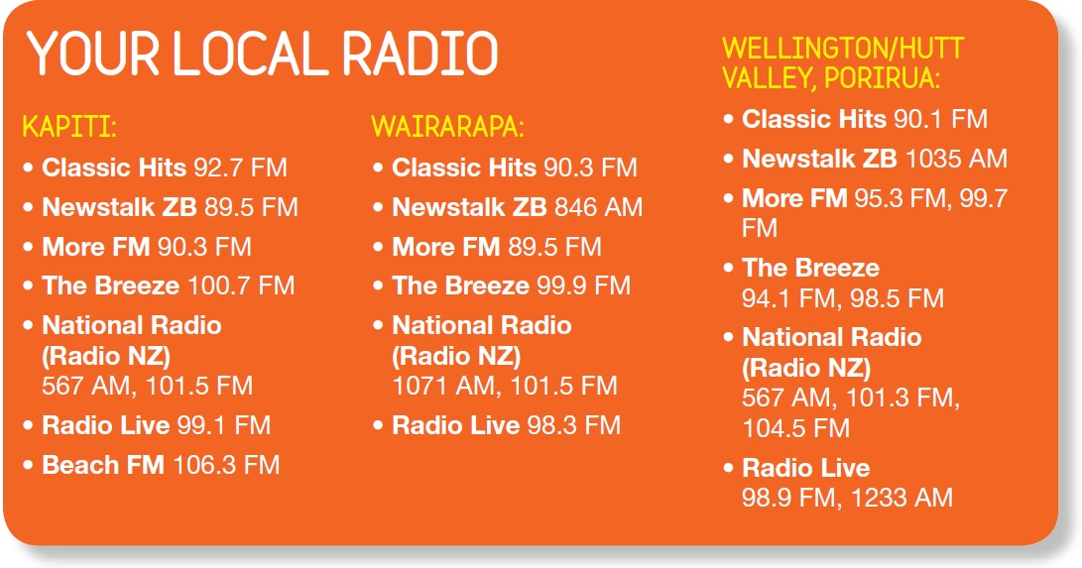Storm/Flooding/Tsunami
- The information desk will monitor weather and decide if the fair will be closed early
- The information desk will notify emergency services
- The information desk will announce fair closure over the PA – this will include information about the state of the weather and the timeframe available/required for evacuation
- Instruct shopkeepers and stallholders to shut off power, gas, and water if there is time to do so

Medical Emergencies
- If you are involved in, or are a witness to an immediate medical emergency (e.g. the collapse of a person), firstly ensure your own safety
- Seek medical assistance immediately, call for an ambulance, and notify the information desk
- Administer first aid treatment only if it is safe to do so, and only in the manner that you have been trained in.

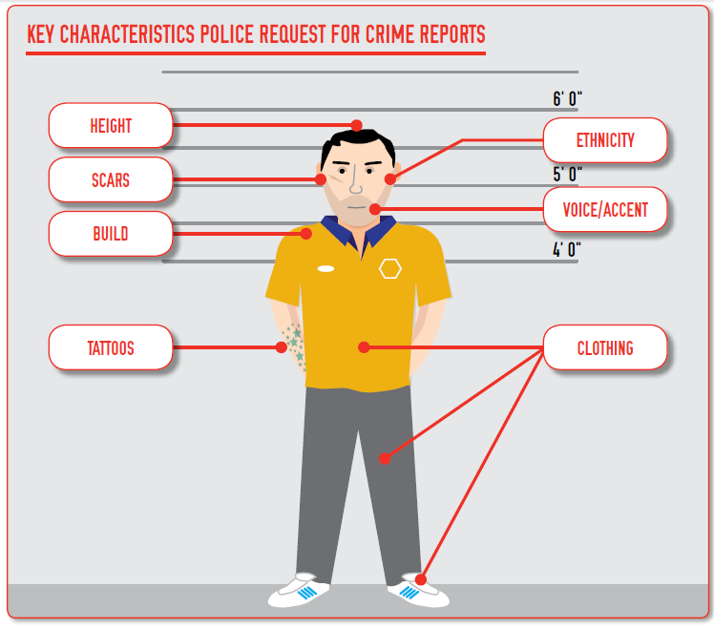
Threatening Behaviour
From ACS Crime Report 2016
- Keep calm, make no sudden movements
- Do what the offender asks (as long as this does not place you or others in more danger)
- Try to memorise as many details about the offender as possible
- Call 111 to notify police, and notify the information desk as soon as it is safe to do so.

Bomb threat
When a bomb threat is received, or a suspicious object is discovered, it must be treated as genuine until proven otherwise.
- Do not touch or move any suspicious object
- Keep calm
- Keep the person talking – don’t interrupt
- Let them feel in charge – keep the person on the line, don’t hang up
- Attract assistance if possible and have this person alert the office and call for police on 111
- Ask about the bomb: where it is, what it looks like, what will trigger it, when will it explode
- Ask about the person: what their name is, where they are
- Evacuate if directed to do so by the NZ Police (but do not hang the phone up on the caller).

Transport and Parking

Road Closure
There will be significant road closures from 6am to 6pm on the day of the fair on Ganges Rd, from Agra Cres to Dekka St.
A traffic management plan is lodged with the Wellington City Council beforehand by a company with a qualified Site Traffic Management Supervisor (STMS), who also provide all the appropriate road closures, signage and supervision during the day. Marshals direct stallholders’ vehicles to their sites. Wellington City Council officers have authority to remove any offending vehicles.
Public are advised by notification published in newspapers, signage, plus posters placed around the greater Khandallah area and local letterbox drop. Emails have been sent to the following organisations, advising road closure with no throughway:
  - Johnsonville Police Station
  - Wellington Free Ambulance
  - Johnsonville Fire Service
  - Greater Wellington Regional Council

Parking
Posters and other public communications will encourage people to take public transport. Offsite carparks will be available for stallholders. The volunteer groups who will manage the offsite carparks will be given relevant health and safety guidelines beforehand.
Greater Wellington Regional Council will advise bus drivers of the possible route disruption.

Relevant Legislation and Guides
Health and Safety at Work Act 2015  Health and Safety at Work Regulations 2016  Accident Compensation Act 2001  Human Rights Act 1993  Privacy Act 1993  Smoke-free Environments Act 1990  Smoke-free Environments Regulations 2007  Misuse of Drugs Regulations 1977  Civil Defence Emergency Management Act 2002  Land Transport (Road User) Rule 2004  Transport (Vehicle and Driver Registration and Licensing) Act 1986  Food Act 2014  Electricity (Safety) Regulations 2010 | http://www.worksafe.govt.nz/worksafe  Occupational Health Guidelines, ACC https://www.acc.co.nz/for-business/workplace-health-safety/  How to Implement Safe Workplace Practices (ACC366 2014)  Health and Safety Management Flowcharts (ACC4440-ACC4445 2014)  Good Governance Practices Guideline for Managing Health and Safety Risks 2013  Police Vetting http://www.police.govt.nz/advice/businesses-and-organisations/vetting  Help yourself prevent and manage discomfort pain and injury 2009  Stress and How to Handle it, Mental Health Foundation of NZ 2002  Bullying, WorkSafe http://www.worksafe.govt.nz/worksafe/toolshed/bullying-prevention-toolbox  Emergency Preparedness http://civildefence.govt.nz/  Emergency Preparedness http://getthru.govt.nz/  Fire Safety http://www.fire.org.nz/  Safe Driving Policy https://www.nzta.govt.nz/assets/resources/your-safe-driving-policy/docs/safe-driving-policy-booklet.pdf  Food Safety, Ministry of Primary Industries http://www.mpi.govt.nz/food-safety

Signed

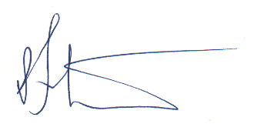 20 November 2019
___________________________ ______________
  - RUSSELL LAW, Fair convener Date
  - Rotary Club of Wellington Kaukau Incorporated

Table: Adapted from Interaction of people, tasks, and environment for hazard analysis (developed from Hay 1992, and OSH 1991: P10) Likelihood scale.
An RT (Radio Telephone, or “Walkie Talkie”) is battery operated, so will still work in a power outage. It is also quicker to use than a cellphone and transmits simultaneously to everyone on the network.

